Anthony Cunningham

STAT 3210

Professor Erning Li

**Homework 5 R Code & Output**

#1.

assemblyTime <- read.table("http://www.stat.uiowa.edu/~ernli/DOEdata/problem0428.txt", header=TRUE)

summary(aov(Time ~ factor(Order) + factor (Operator) + Method, assemblyTime))

Df Sum Sq Mean Sq F value Pr(>F)

factor(Order) 3 18.5 6.167 3.524 0.08852 .

factor(Operator) 3 51.5 17.167 9.810 0.00993 **

Method 3 72.5 24.167 13.810 0.00421 **

Residuals 6 10.5 1.750

summary(aov(Time ~ factor(Order) + Method, assemblyTime))

Df Sum Sq Mean Sq F value Pr(>F)

factor(Order) 3 18.5 6.167 0.895 0.4803

Method 3 72.5 24.167 3.508 0.0625 .

Residuals 9 62.0 6.889

summary(aov(Time ~ factor (Operator) + Method, assemblyTime))

Df Sum Sq Mean Sq F value Pr(>F)

factor(Operator) 3 51.5 17.167 5.328 0.02195 *

Method 3 72.5 24.167 7.500 0.00806 **

Residuals 9 29.0 3.222

summary(aov(Time ~ Method, assemblyTime))

Df Sum Sq Mean Sq F value Pr(>F)

Method 3 72.5 24.167 3.602 0.046 *

Residuals 12 80.5 6.708

par(mfrow = c(2,2))

plot(aov(Time ~ factor(Operator) + factor(Order) + Method, data=assemblyTime))

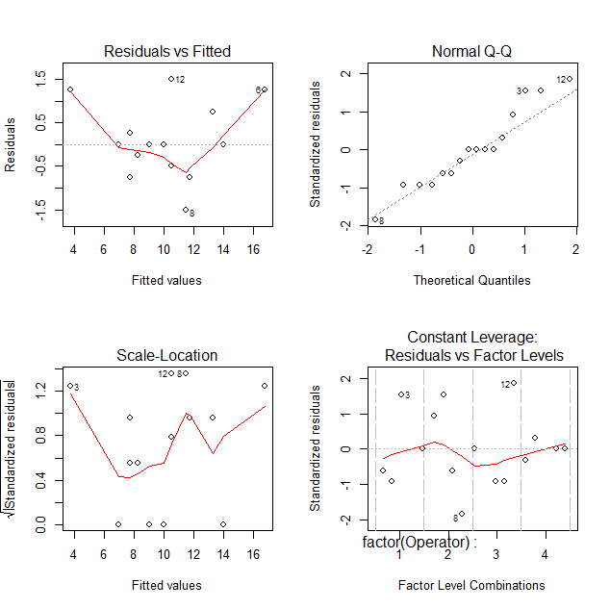

assemblyTimeLM = lm(Time ~ factor(Order) + factor (Operator) + Method, assemblyTime)

nonadd = predict(assemblyTimeLM)^2

anova(update(assemblyTimeLM, . ~ . + nonadd))

Response: Time

Df Sum Sq Mean Sq F value Pr(>F)

factor(Order) 3 18.500 6.1667 7.1431 0.029485 *

factor(Operator) 3 51.500 17.1667 19.8847 0.003293 **

Method 3 72.500 24.1667 27.9930 0.001494 **

nonadd 1 6.183 6.1835 7.1625 0.044016 *

Residuals 5 4.317 0.8633

library(emmeans)

emmeans(assemblyTimeLM, pairwise ~ Method, adjust="none")

$contrasts

contrast estimate SE df t.ratio p.value

A - B -1.75 0.9354143 6 -1.871 0.1106

A - C -5.75 0.9354143 6 -6.147 0.0008

A - D -3.50 0.9354143 6 -3.742 0.0096

B - C -4.00 0.9354143 6 -4.276 0.0052

B - D -1.75 0.9354143 6 -1.871 0.1106

C - D 2.25 0.9354143 6 2.405 0.0529

critValue = sqrt(0.5)*qtukey(0.95,4,6)

SE = sqrt((2*1.75)/4)

(HSD = critValue*SE)

[1] 3.238134

emmeans(assemblyTimeLM, pairwise ~ Method)

$contrasts

contrast estimate SE df t.ratio p.value

A - B -1.75 0.9354143 6 -1.871 0.3304

A - C -5.75 0.9354143 6 -6.147 0.0035

A - D -3.50 0.9354143 6 -3.742 0.0364

B - C -4.00 0.9354143 6 -4.276 0.0203

B - D -1.75 0.9354143 6 -1.871 0.3304

C - D 2.25 0.9354143 6 2.405 0.1761

library(lme4)

assemblyTime.lmer = lmer(Time ~ (1|Operator) + (1|Order)+ Method, data=assemblyTime)

summary(assemblyTime.lmer)

Linear mixed model fit by REML ['lmerMod']

Formula: Time ~ (1 | Operator) + (1 | Order) + Method

Data: assemblyTime

REML criterion at convergence: 56.9

Random effects:

Groups Name Variance Std.Dev.

Operator (Intercept) 3.854 1.963

Order (Intercept) 1.104 1.051

Residual 1.750 1.323

Number of obs: 16, groups: Operator, 4; Order, 4

emmeans(assemblyTime.lmer, pairwise~Method, adjust="none")

Loading required namespace: pbkrtest

$contrasts

contrast estimate SE df t.ratio p.value

A - B -1.75 0.9354143 6 -1.871 0.1106

A - C -5.75 0.9354143 6 -6.147 0.0008

A - D -3.50 0.9354143 6 -3.742 0.0096

B - C -4.00 0.9354143 6 -4.276 0.0052

B - D -1.75 0.9354143 6 -1.871 0.1106

C - D 2.25 0.9354143 6 2.405 0.0529

emmeans(assemblyTime.lmer, pairwise~Method)

$contrasts

contrast estimate SE df t.ratio p.value

A - B -1.75 0.9354143 6 -1.871 0.3304

A - C -5.75 0.9354143 6 -6.147 0.0035

A - D -3.50 0.9354143 6 -3.742 0.0364

B - C -4.00 0.9354143 6 -4.276 0.0203

B - D -1.75 0.9354143 6 -1.871 0.3304

C - D 2.25 0.9354143 6 2.405 0.1761

assemblyTimeMissing <- assemblyTime

assemblyTimeMissing ["1", "Time"] <- NA

assemblyTimeMissing ["14", "Time"] <- NA

summary(aov(Time ~ factor(Operator) + factor(Order) + Method, assemblyTimeMissing))

Df Sum Sq Mean Sq F value Pr(>F)

factor(Operator) 3 55.35 18.448 7.924 0.0370 *

factor(Order) 3 34.08 11.361 4.880 0.0799 .

Method 3 48.69 16.229 6.971 0.0457 *

Residuals 4 9.31 2.328

#2

assemblyTimeGLS <- read.table("http://www.stat.uiowa.edu/~ernli/DOEdata/problem0441.txt", header=TRUE)

summary(aov(Time ~ factor(Order) + factor (Operator) + Workplace + Method, assemblyTimeGLS)

Df Sum Sq Mean Sq F value Pr(>F)

factor(Order) 3 0.5 0.17 0.018 0.996

factor(Operator) 3 19.0 6.33 0.691 0.616

Workplace 3 7.5 2.50 0.273 0.843

Method 3 95.5 31.83 3.473 0.167

Residuals 3 27.5 9.17

#3

reactionTime <- read.table("http://www.stat.uiowa.edu/~ernli/DOEdata/problem0427.txt", header=TRUE)

summary(aov(Time ~ factor(Batch) + factor(Day) + Catalyst, reactionTime))

Df Sum Sq Mean Sq F value Pr(>F)

factor(Batch) 4 15.44 3.86 1.235 0.347618

factor(Day) 4 12.24 3.06 0.979 0.455014

Catalyst 4 141.44 35.36 11.309 0.000488 ***

Residuals 12 37.52 3.13